PART I (VISUALS) VALUE 25%
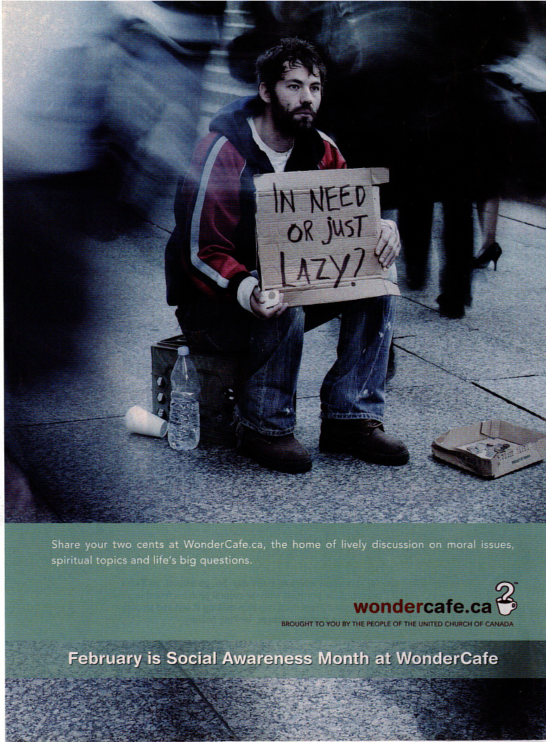
In this part of the examination, there are three visuals. Examine the visuals and answer the questions that follow. For each selected response question, circle the correct or best answer. For the constructed response questions, write your answer in the space provided, using complete sentences.

Selected Response Questions:
Circle the correct or best answer. (5%)

- What is the logo for the visual?

  - in need or just lazy
  - mug and question mark
  - social awareness month
  - wondercafe.ca

- What is the purpose of the visual?

  - donate money
  - provide instruction
  - religious awareness
  - social awareness

- What form of figurative language is the phrase “share your two cents”?

  - hyperbole
  - metaphor
  - onomatopoeia
  - oxymoron

- What best describes the phrase, “the home of lively discussion”?

  - allusion
  - imagery
  - irony
  - symbolism

- Which word best represents the character in the visual?

  - ambitious
  - confused
  - determined
  - stereotyped

Constructed Response:
Write your answer in the space provided.

- How does the author develop the focal point? Provide two references to support your answer. (5%)
___________________________________________________________________________________________________________________________________________________________________________________________________________________________________________________________________________________________________________________________________________________________________________________________________________________________________________________________________________________________________________________________________________________________________________________________________________________________________________________________________________________________________________________________________________________________________________________________________________________________________________________________________

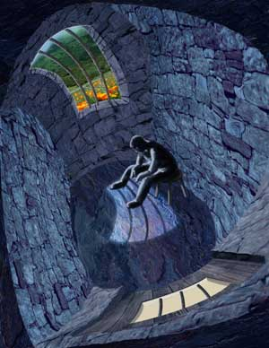

Selected Response Questions:
Circle the correct or best answer. (5%)

- What is the form of the visual?

  - painting
  - photograph
  - pixel
  - poster

- What element is best established by looking down over the bricks?

  - colour
  - line
  - perspective
  - scale

- What is the background?

  - field
  - floor
  - walls
  - windows

- What is the mood of the visual?

  - happy
  - hopeful
  - somber
  - sunny

- What best establishes horizontal balance?

  - bricks
  - person
  - stool
  - windows

Constructed Response:
Write your answer in the space provided.

- How does the author use symbolism? Provide two references to support your answer. (5%)
________________________________________________________________________________________________________________________________________________________________________________________________________________________________________________________________________________________________________________________________________________________________________________________________________________________________________________________________________________________________________________________________________________________________________________________________________________________________________________________________________________________________________________________________________________________________________________________________________________________________________________________________________________________________________________________________________________

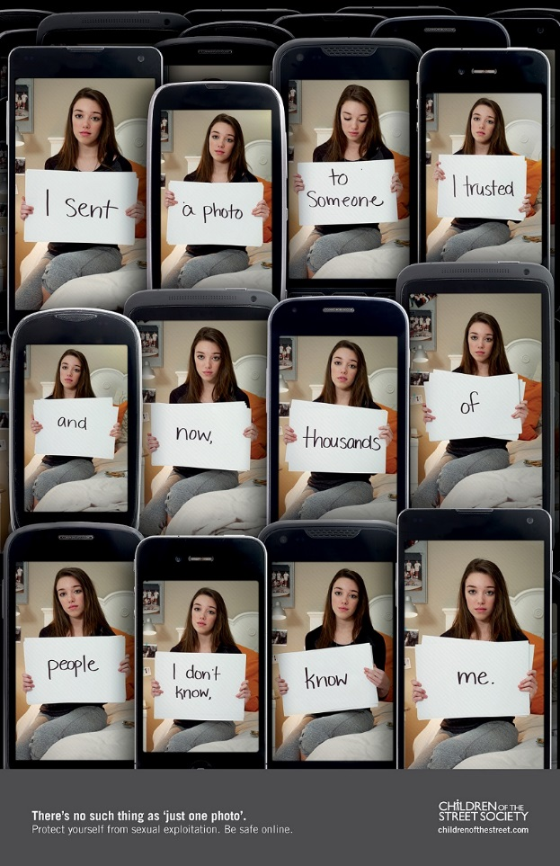

Selected Response Questions:
Circle the correct or best answer. (2%)

- What is the caption of the visual?

  - childrenofthestreet.com
  - Children of the Street Society
  - There’s no such thing as ‘just one photo’
  - Protect yourself from sexual exploitation. Be safe online.

- What is best established by the repetition of the images and the phones?

  - contrast
  - scale
  - setting
  - theme

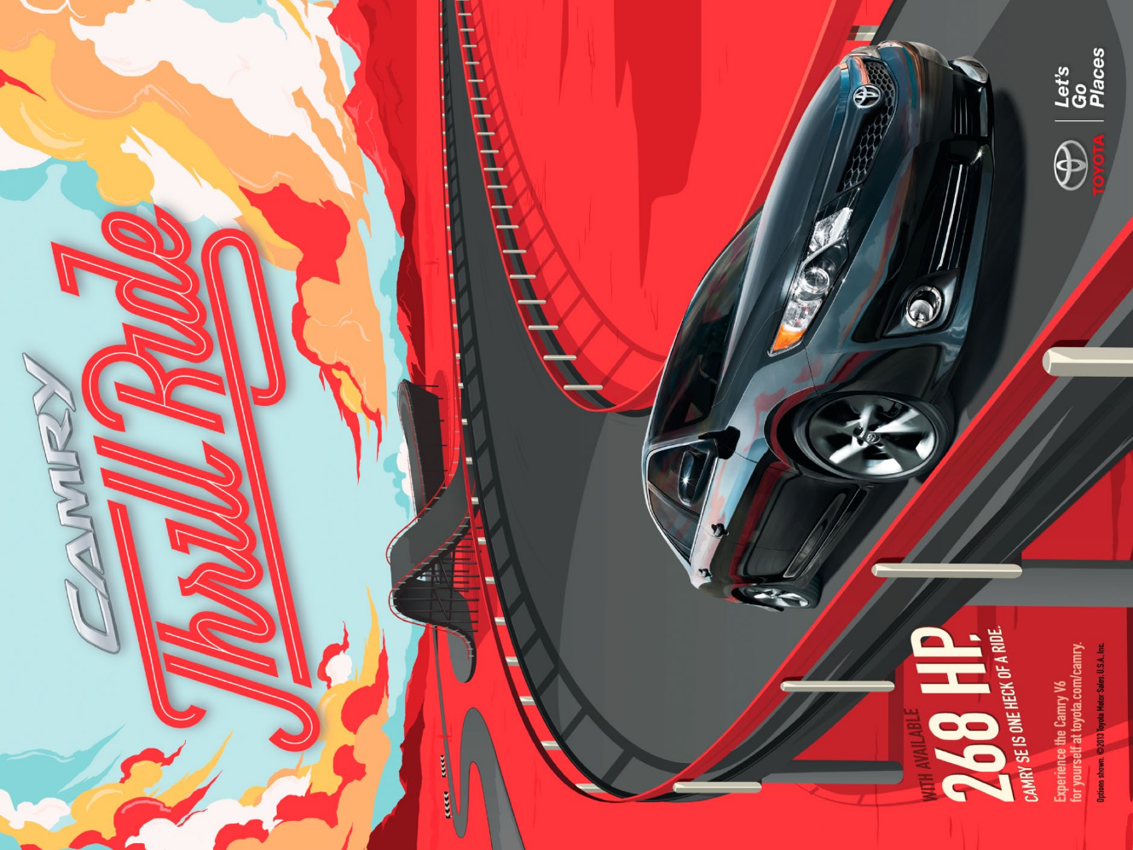

Selected Response Questions:
Circle the correct or best answer. (3%)

- What object is in the foreground?

  - car
  - clouds
  - road
  - sky

- What element best creates a sense of direction?

  - colour
  - focal point
  - font
  - line

- What element is best achieved by the road?

  - balance
  - focal point
  - perspective
  - scale

PART II (PROSE) Value 11%
In this part of the examination, there are five selected response questions, each with a value of one mark, and one constructed response questions with a value of six marks. Read the prose and answer the questions that follow. For each selected-response question, circle the correct or best answer. For the constructed response question, write your answers in the space provided using complete sentences.

The Fire on the Mountain
by Harold Courlander and Wolf Leslau

- People say that in the old days in the city of Addis Ababa there was a young man by the name of Arha. He had come as a boy from the country of Guragé, and in the city he became the servant of a rich merchant, Haptom Hasei.
- Haptom Hasei was so rich that he owned everything that money could buy, and often he was very bored because he had tired of everything he knew, and there was nothing new for him to do.
- One cold night, when the damp wind was blowing across the plateau, Haptom called to Arha to bring wood for the fire. When Arha was finished, Haptom began to talk.
- “How much cold can a man stand?” he said, speaking at first to himself. “I wonder if it would be possible for a man to stand on the highest peak, Mount Sululta, where the coldest winds blow, through an entire night without blankets or clothing and yet not die?”
- “I don’t know,” Arha said. “But wouldn’t it be a foolish thing?”
- “Perhaps, if he had nothing to gain by it, it would be a foolish thing to spend the night that way,” Haptom said. “But I would be willing to bet that a man couldn’t do it.”
- “I am sure a courageous man could stand naked on Mount Sululta throughout an entire night and not die of it,” Arha said. “But as for me, it isn’t my affair, since I’ve nothing to bet.”
- “Well, I’ll tell you what,” Haptom said. “Since you are so sure it can be done, I’ll make a bet with you anyway. If you can stand among the rocks of Mount Sululta for an entire night without food or water or clothing or blankets or fire, and not die of it, then I will give you ten acres of good farmland for your own, with a house and cattle.”
- Arha could hardly believe what he had heard.
- “Do you really mean this?” he asked.
- “I am a man of my word,” Haptom replied.
- “Then tomorrow night I will do it,” Arha said, “and afterwards, for all the years to come, I shall till my own soil.”
- But he was very worried, because the wind swept bitterly across that peak. So in the morning Arha went to a wise old man from the Guragé tribe and told him of the bet he had made. The old man listened quietly and thoughtfully, and when Arha had finished, he said:
- “I will help you. Across the valley from Sululta is a high rock which can be seen in the daytime. Tomorrow night, as the sun goes down, I shall build a fire there, so that it can be seen from where you stand on the peak. All night long you must watch the light of my fire. As you watch my fire, think of its warmth, and think of me, your friend, sitting there tending it for you. If you do this you will survive, no matter how bitter the night wind.”
- Arha thanked the old man warmly and went back to Haptom’s house with a light heart. He told Haptom he was ready, and in the afternoon Haptom sent him, under the watchful eyes of other servants, to the top of Mount Sululta. There, as night fell, Arha removed his clothes and stood in the damp, cold wind that swept across the plateau with the setting sun. Across the valley, several miles away, Arha saw the light of his friend’s fire, which shone like a star in the blackness.
- The wind turned colder and seemed to pass through his flesh and chill the marrow of his bones. The rock on which he stood felt like ice. Each hour numbed him more, until he thought he would never be warm again, but he kept his eyes upon the twinkling light across the valley and remembered that his old friend sat there tending a fire for him. Sometimes wisps of fog blotted out the light, and then he strained to see until the fog passed. He sneezed and coughed and shivered and began to feel ill. Yet all night though he stood there, and only when the dawn came did he put on his clothes and go down the mountain back to Addis Ababa.
- Haptom was very surprised to see Arha, and he questioned his servants thoroughly.
- “Did he stay all night without food or drink or blankets or clothing?”
- “Yes,” his servants said. “He did all of those things.”
- “Well, you are a strong fellow,” Haptom said to Arha. “How did you manage to do it?”
- “I simply watched the light of a fire on a distant hill,” Arha said.
- “What? You watched a fire? Then you lose the bet, and you are still my servant, and you own no land.”
- “But the fire was not close enough to warm me, it was far across the valley.”
- “I won’t give you the land,” Haptom said. “You didn’t fulfill the conditions. It was only the fire that saved you.”
- Arha was very sad. He went again to his old friend of the Guragé tribe and told him what had happened.
- “Take the matter to the judge,” the old man advised him.
- Arha went to the judge and complained, and the judge sent for Haptom. When Haptom told his story, and the servants said once more that Arha had watched a distant fire across a valley, the judge said, “No, you have lost, for Haptom Hasei’s condition was that you must be without fire.”
- Once more Arha went to his old friend with the sad news that he was doomed to the life of a servant, as though he had not gone through the ordeal of the mountaintop.
- “Don’t give up hope,” the old man said. “More wisdom grows wild in the hills than in any city judge.”
- He got up from where he sat and went to find a man named Hailu, in whose house he had been a servant when he was young. He explained to the good man about the bet between Haptom and Arha, and asked if something couldn’t be done.
- “Don’t worry about it,” Hailu said after thinking for a while. “I will take care of it for you.”
- Some days later Hailu sent invitations to many people in the city to come to a feast at his house. Haptom was among them, and so was the judge who had ruled Arha had lost the bet.
- When the day of the feast arrived, the guests came riding on mules with fine trappings, their servants strung behind them on foot. Haptom came with twenty servants, one of whom held a silk umbrella over his head to shade him from the sun, and four drummers played music that signified the great Haptom was here.
- The guests sat on soft rugs laid out for them and talked. From the kitchen came the odors of wonderful things to eat: roast goat, roast corn and durra, pancakes (called injera), and many tantalizing sauces. The smell of the food only accentuated the hunger of the guests. Time passed. The food should have been served, but they didn’t see it, only smelled vapors that drifted from the kitchen. The evening came, and still no food was served. The guests began to whisper among themselves. It was very curious that the honorable Hailu had not had the food brought out. Still the smells came from the kitchen. At last one of the guests spoke out for all the others, “Hailu, why do you do this to us? Why do you invite us to a feast and then serve us nothing?”
- “Why, can’t you smell the food?” Hailu asked with surprise.
- “Indeed, we can, but smelling is not eating, there is no nourishment in it.”
- “And is there warmth in a fire so distant that it can hardly be seen?” Hailu asked. “If Arha was warmed by the fire he watched while standing on Mount Sululta, then you have been fed by the smells coming from my kitchen.”
- The people agreed with him; the judge now saw his mistake, and Haptom was ashamed. He thanked Hailu for his advice, and announced that Arha was then and there the owner of the land, the house, and the cattle. Then Hailu ordered the food brought in, and the feast began.
Selected Response Questions:
Circle the correct or best answer. (5%)

- Addis Ababa is what type of figurative language?

  - alliteration
  - allusion
  - annotation
  - assonance

- What is the point of view in this text?

  - first person
  - second person
  - third person limited
  - third person omniscient

- “He sneezed and coughed and shivered” (paragraph 16) is what type of literary device?

  - complex sentence
  - Onomatopoeia
  - iambic pentameter
  - parallelism

- In the context of the sentence and paragraph, what does “accentuate” (paragraph 34) mean?

  - decrease
  - highlight
  - increase
  - satisfied

- What word best describes the character of Arha?

  - careful
  - determined
  - lazy
  - unimaginative

Constructed Response:
Write your answer in the space provided.

- State a possible theme for The Fire on the Mountain. Support you answer with reference to the title and one from the text. (6%)
________________________________________________________________________________________________________________________________________________________________________________________________________________________________________________________________________________________________________________________________________________________________________________________________________________________________________________________________________________________________________________________________________________________________________________________________________________________________________________________________________________________________________________________________________________________________________________________________________________________________________________________________________________________________________________________________________________

PART III (POETIC TEXT) VALUE 14%
In this part of the examination, there are nine selected response questions, each with a value of one mark, and one constructed response question with a value of six marks. Read the poem and answer the questions that follow. For each selected response question, circle the correct or best answer. For the constructed response question, write your responses in the space provided using complete sentences.

Then
poverty teaches no one
it's just dark and small
like a revolver
always ready to be
the final judge | 5
i remember dirty walls
macaroni, television and
dumping the slop pail
there was no beauty
you just survived | 10
between paydays
my father
drank every Friday
and Saturday nights
he lived between the | 15
borders of the day shift
and the night shift
that was the only
structure i knew
i know now | 20
that he sold
what little of himself
he had so that i could eat
what kind of change is that?
where one generation sacrifices | 25
itself so that the next one
can walk on its bones
with a new pair of shoes.

by Robert Hilles.

Selected Response Questions:
Shade the letter of the correct or best response.

- What is the form of the poem?

- free verse
- ballad
- blank verse
- sonnet

- “it’s just dark and small / like a revolver” (lines 2-3) is what type of figurative language?

  - hyperbole
  - metaphor
  - personification
  - simile

- “a revolver / always ready to be / the final judge” (lines 2-5) is what type of figurative language?

- onomatopoeia
- oxymoron
- personification
- understatement

- Which best describes “what kind of change is that?” (line 24)?

- colloquial
- lyrical
- literal
- rhetorical

- “dirty walls / macaroni, television and / dumping the slop pail” (lines 6-8) is an example of which literary device?

- alliteration
- hyperbole
- metaphor
- parallelism

- Which best describes the change in tone in the poem?

- harsh to despair
- reflective to pessimistic
- resentful to appreciative
- thankful to bitter

- What does the narrator mean in lines 21-22, “that he sold / what little of himself he had”?

- auctioned himself to the highest bidder
- compromised his goals
- forfeited his own dreams
- sold himself into slavery

- What is the significance of the title?

- develops dramatic irony
- emphasizes perspective
- illustrates setting
- indicates the past

- What do the shoes symbolize?

- better life
- cruel acts
- greed
- sacrifice

Constructed Response:
Write your answers in the space provided.

- How does the speaker’s maturity affect his/her view of the father? Support your response with two references to the selection. (5%)
________________________________________________________________________________________________________________________________________________________________________________________________________________________________________________________________________________________________________________________________________________________________________________________________________________________________________________________________________________________________________________________________________________________________________________________________________________________________________________________________________________________________________________________________________________________________________________________________________________________________________________________________________________________________________________________________________________________________________________________________________________________________________________________________________________________________________

PART IV (ESSAY) VALUE 25%

Responses are marked on the basis of the arguments presented, the specific references to the chosen work (content), organization, sentence fluency, voice, word choice, and conventions.

- Authors often try to teach us truths about ourselves or our own society. In a well-written, multi-paragraph essay, state and appropriate theme for one of the novels OR longer play studied this year. Be sure to use specific references to the text to demonstrate how that theme is developed.

Novels | Longer Play
The Giver | A Midsummer Night’s Dream
A Christmas Carol
To Kill a Mockingbird
Animal Farm
The Blue Helmet
Overdrive

ESSAY PLANNING SPACE
(will NOT be graded)

____________________________________________________________________________________________________________________________________________________________________________________________________________________________________________________________________________________________________________________________________________________________________________________________________________________________________________________________________________________________________________________________________________________________________________________________________________________________________________________________________________________________________________________________________________________________________________________________________________________________________________________________________________________________________________________________________________________________________________________________________________________________________________________________________________________________________________________________________________________________________________________________________________________________________________________________________________________________________________________________________________________________________________________________________________________________________________________________________________________________________________________________________________________________________________________________________________________________________________________________________________________________________________________________________________________________________________________________________________________________________________________________________________________________________________________________________________________________________________________________________________________________________________________________________________________________________________________________________________________________________________________________________________________________________________________________________________________________________________________________________________________________________________________________________________________________________________________________________________________________________________________________________________________________________________________________________________________________________________________________________________________________________________________________________________________________________________________________________________________________________________________________________________________________________________________________________________________________________________________________________________________________________________________________________________________________________________________________________________________________________________________________________________________________________________________________________________________________________________________________________________________________________________________________________________________________________________________________________________________________________________________________________________________________
___________________________________________________________________________________________________________________________________________________________________________________________________________________________________________________________________________________________________________________________________________________________________________________________________________________________________________________________________________________________________________________________________________________________________________________________________________________________________________________________________________________________________________________________________________________________________________________________________________________________________________________________________________________________________________________________________________________________________________________________________________________________________________________________________________________________________________________________________________________________________________________________________________________________________________________________________________________________________________________________________________________________________________________________________________________________________________________________________________________________________________________________________________________________________________________________________________________________________________________________________________________________________________________________________________________________________________________________________________________________________________________________________________________________________________________________________________________________________________________________________________________________________________________________________________________________________________________________________________________________________________________________________________________________________________________________________________________________________________________________________________________________________________________________________________________________________________________________________________________________________________________________________________________________________________________________________________________________________________________________________________________________________________________________________________________________________________________________________________________________________________________________________________________________________________________________________________________________________________________________________________________________________________________________________________________________________________________________________________________________________________________________________________________________________________________________________________________________________________________________________________________________________________________________________________________________________________________________________________________________________________________________________________________________________________________________________________________________________________________________________________________________________________________________________________________________________________________________________________________________________________________________________________________________________________________________________________________________________________________________________________________________________________________________________________________________________________________________________________________________________________________________________________________________________________________________________________________________________________________________________________________________________________________________________________________________________________________________________________________________________________________________________________________________________________________________________________________________________________________________________________________________________________________________________________________________________________________________________________________________________________________________________________________________________________________________________________________________________________________________________________________________________________________________________________________________________________________________________________________________________________________________________________________________________________________________________________________________________________________________________________________________________________________________________________________________________________________________________________________________________________________________________________________________________________________________________________________________________________________________________________________________________________________________________________________________________________________________________________________________________________________________________________________________________________________________________________________________________________________________________________________________________________________________________________________________________________________________________________________________________________________________________________________________________________________________________________________________________________________________________________________________________________________________________________________________________________________________________________________________________________________________________________________________________________________________________________________________________________________________________________________________________________________________________________________________________________________________________________________________________________________________________________________________________________________________________________________________________________________________________________________________________________________________________________________________________________________________________________________________________________________________________________________________________________________________________________________________________________________________________________________________________________________________________________________________________________________________________________________________________________________________________________________________________________________________________________________________________________________________________________________________________________________________________________________________________________________________________________________________________

