English 3201 – Sample Comparative Essays

1. With reference to one longer play and one work from the prescribed texts below, show how a character has gained valuable insights into his/her experiences.

Key Points:
• Students must choose a character from each text.
• Students must focus on at least two major examples per character.
• Students must discuss each character with specific references to the prescribed texts.
• Students must use a good introduction and a good conclusion.
• Students must use a smooth transition from discussion of one text to another.
• An extremely well-written plot summary will only receive a maximum of 12.5 marks.

Score 25/25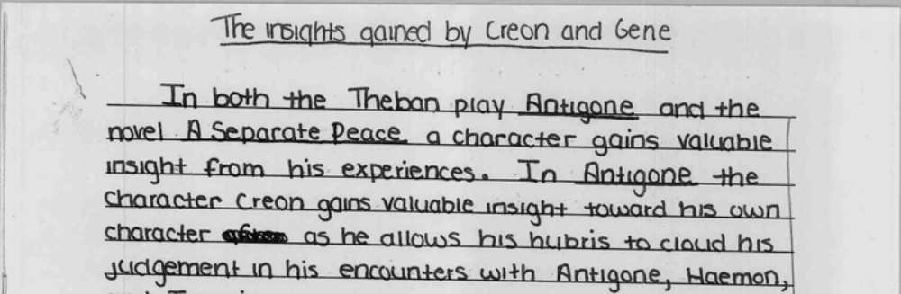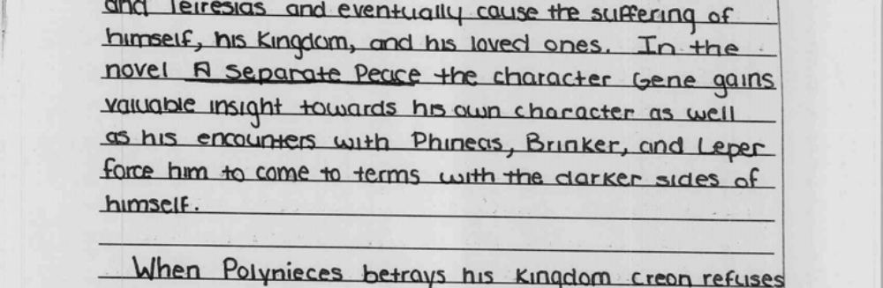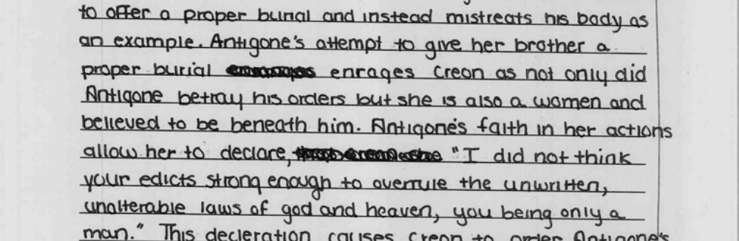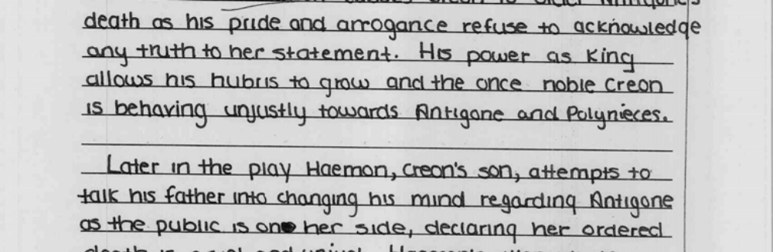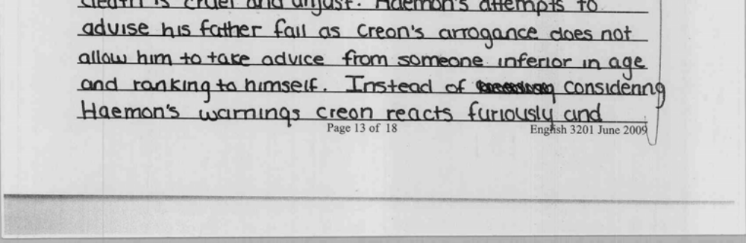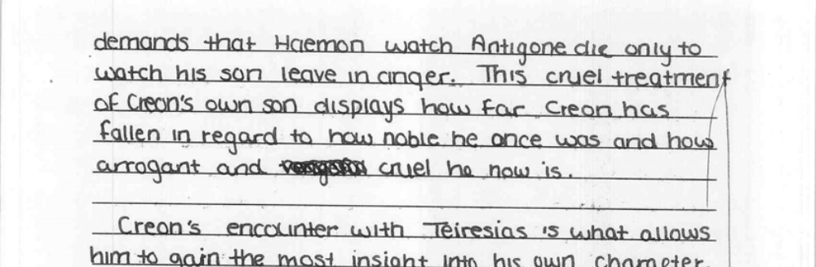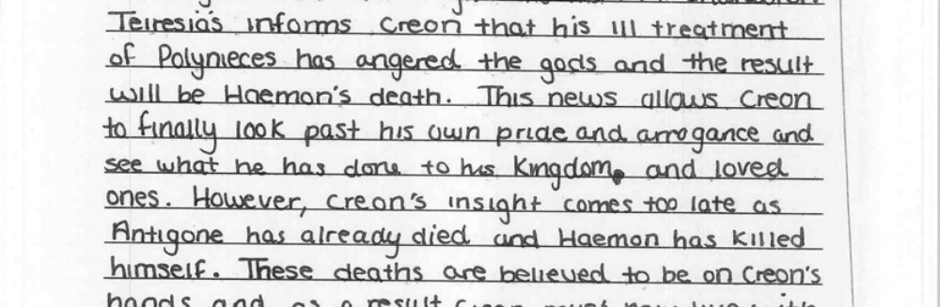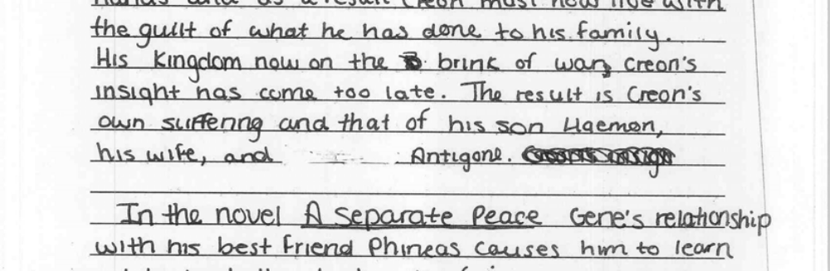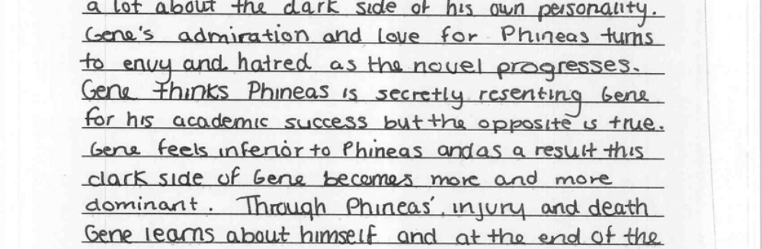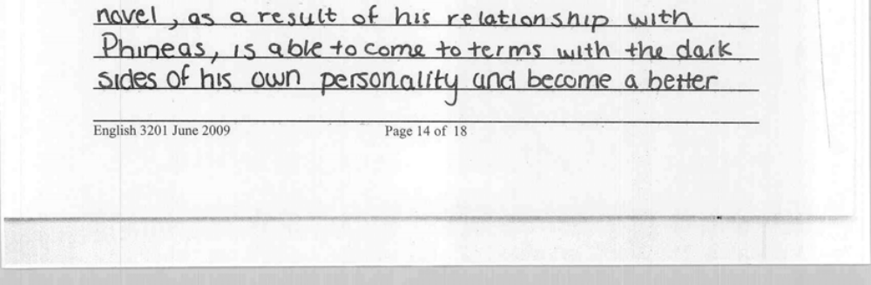

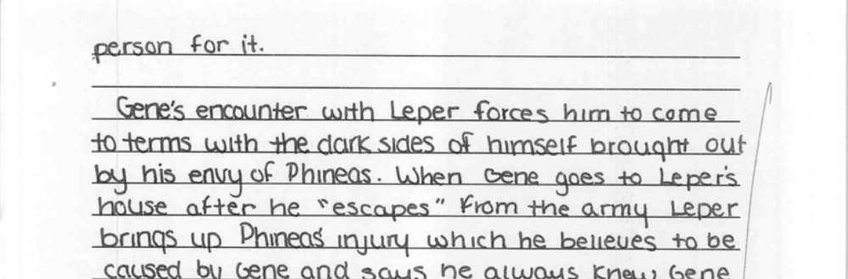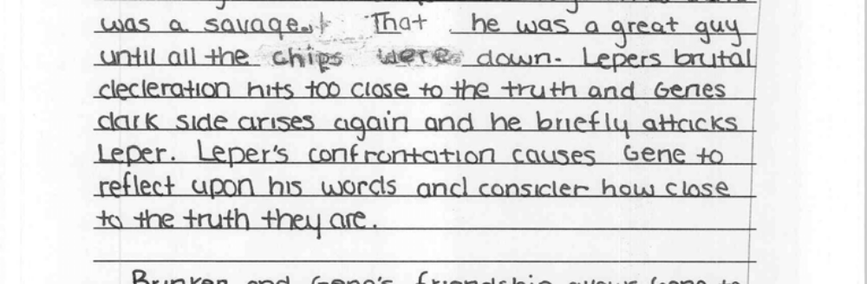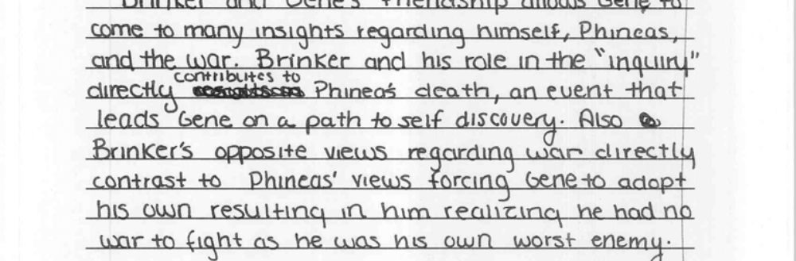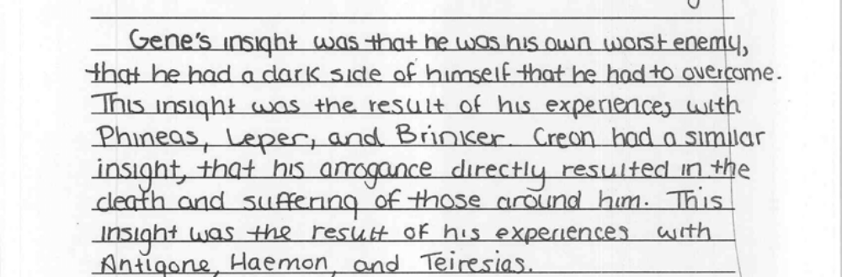

English 3201 – Sample Comparative Essays

2. With reference to one longer play and one prescribed text from the list below, show
how the development of alienated or isolated characters contribute to the development of theme in each selection . Use specific references from both works.

Key Points:
• Students must choose a character from each text.
• Students must focus on at least two major examples per character.
• Students must discuss each character with specific references to the prescribed texts.
• Students must use a good introduction and a good conclusion.
• Students must use a smooth transition from discussion of one text to another.
• An extremely well-written plot summary will only receive a maximum of 12.5 marks.

Score 20/25


