English 3201
2012 Common Mid-Year Examination

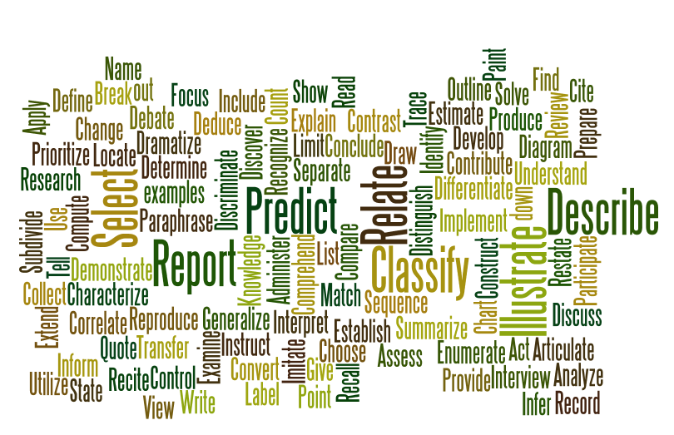

SECTION A: SIGHT PASSAGE
PART I-VISUAL: 11%

Selected Response - 1% Each
1. D (Outcome 7.2)
2. D (4.3)
3. A (6.1)
4. D (7.4)
5. D (6.1)

Constructed Response – 6%
6. Explain how any two visual elements contributed to the overall message of the visual. For each element provide one specific reference. (Outcome 6.1)

Answers will vary; all answers should be considered.
Possible theme or message may include one of the following:
- Plastic surgery is dangerous
- Plastic surgery is a game of chance
- Decisions can have far reaching effects
- Youth are becoming targets for plastic surgery
- Youth will go to extreme lengths for acceptance, beauty etc…

Visual Elements - references
Color – red on flesh, yellow knives, red and blue text
Contrast – red on flesh, red and blue text
Balance – two hands, two knives
Symmetry – arrangement of face, hands and knives in visual
Focal point – the game
Perspective – blurred hands with clear game on face

Evaluation
2% overall message
1% each reference
1% each explanation

PART II: PROSE-20%
Selected Response - 1% each
7. C (7.1)
8. C (7.5)
9. D (4.5)
10. A (4.3)
11. A (4.3)
12. A (4.5)
13. C 9.2 & 10.1
14. B (7.5)

Constructed Response - 6% each
15. Identify two methods used by the essayist to create coherence. Support your answer with one specific reference for each method.
Possible methods may include the following: (Suggested answers only)
Methods - references
- Logical order – moves from historically through to today.
- use of examples – statistics through essay
- use of comparison/contrast – Paragraph 9
- temporal references – Historically, Traditionally & Today, Recent research (paragraph 4)
- Use of transitions/connectives – section headings, transitional words between paragraphs 8-9 and 10-11
- Repetition of key words – “Ideal”

Evaluation
1% for each method
1% for each reference
1% for each explanation

16. What is the significance of the word “Mask” used in the title and throughout the selection? Support your answer with two specific references. (6.2, 8.1)
Significance - References
- Symbolizes the hidden issue
- “men’s body image dissatisfaction has tripped in previous 25 years” paragraph 3.
- “Secret phenomenon” paragraph 12.
- “The man behind the mask: Male body image dissatisfaction” Title
- Symbolize changing roles :
- Paragraph 2 “... men were defined by their jobs... their bodies are one of the few remaining ways in which they can differentiate themselves from women”
- Represents a barrier/something to hide behind
- “...pressure to conform” paragraph 5.
- “... men and boys are less equipped or willing to address such traditionally female concerns” paragraph 9
- “excessive exercise and working out to mask the feelings of inadequacy associated with body image dissatisfaction is without questions unhealthy” paragraph 10
- It’s not okay to show who you are
- “dissatisfaction often goes unnoticed by family and friends” paragraph 10
- For men its perceived to be ok to exercise
- “excessive exercise and working out to mask the feelings of inadequacy associated with body image dissatisfaction is without questions unhealthy” paragraph 10
- Represents societal perceptions
- “behaviours are seen as culturally acceptable in males” paragraph 10
- Represents medias projected “ideal”
- “The weight of the media” section heading
- “idealized image of what it means to be a male” paragraph 6
Evaluation
2% Significance of the word “Mask”
1% reference
1% explanation
1% reference
1% explanation

PART III: POETIC TEXT-19%
Selected Response- 1% each
17. B (7.2)
18. C (4.3)
19. D 4.4, 4.5
20. B (4.5/7.4)
21. A (4.5/7.4)
22. A (7.4)
23. B 6.2, 4.4

Constructed Response- 6%each
24. Identify the emotional state of the speaker in At Seventeen. Provide two specific references to support your answer. (7.4, 7.5,)

Emotional state:
- Acceptance, resignation, exclusion, depression, sadness, rejection, marginalization, defeat
References:
- “I learned the truth at seventeen”
- “Ugly duckling girls like me”
- “Those of us with ravaged faces…”
- “And those whose names were never called when choosing sides for basketball”,
- “To those of us who know the pain of valentines that never came”
- “cheat ourselves at solitaire”
- “Inventing lovers on the phone” etc.

Evaluation: 2% - Identify emotional state
2% - Reference #1 with explanation
2% - Reference #2 with explanation

25. Explain the effectiveness of repetition in the poem. Use two specific references to support your answer. (7.4)
Effectiveness:
- Reinforces the tone
- Reinforces the theme
- Provides emphasis

References:
- “At Seventeen”
- “I learned the truth”
- “Ugly girls like me”
- “Come dance with me”
- “Valentines”
- “Inventing lover’s on the phone”
- “murmured vague obscenities”

Evaluation: 2% - Effectiveness of repetition
2% - Reference #1 with explanation
2% - Reference #2 with explanation

Connections - 10%
26. In two well-developed paragraphs, compare the tone of the poem, “At Seventeen” and the visual. Use one specific reference from each selection to show comparison and one specific reference from each to show contrast.
Tone
- Similar tones: negative, critical, serious, bitterness,
References:
Visual
- “Plastic surgery: not a game”
- Color red = danger
- Using knives to cut face
- Game played in blood
Poem
- “Ravaged faces”
- “to those of us who know the pain of valentines that never came”
- “ugly duckling girls like me”

- Different tones: Rejection/acceptance, permanent/transitional, urgency/complacency
References:
Poem
- “we all play the game”
- “I learned the truth”
- “pity please, the ones who serve, they only get what they deserve”
- “It isn’t all it seems at 17”
Visual
- Text-“not a game”
- Cutting/surgery/scars are permanent

Evaluation:
2% - statement of tone
1% - reference to visual
1% - explanation
1% - reference to poem
1% explanation
Difference
1% - reference to visual
1% - explanation
1% - reference to poem
1% - explanation
SECTION B: COMPARATIVE STUDY-25%
27. In literary works characters often meet with either success or failure. With reference to one major character from two of the longer works listed, discuss which factors led to the success or failure of the character.
English Scoring Scale Criteria
Literature | Score |  | Language |  | Score
- content displays an outstanding knowledge of subject matter  - choice of content is consistently clear, specific and serves to answer the question  - selections are consistently supported with detailed references that relate to the task |  | 9-10 |  | - introduction is compelling  - conclusion reinforces unity in a compelling way  - structure (responses is nearly flawless with ideas that re logically sequenced and developed)  - mechanics (response is almost error-free) | 9-10
- content displays a strong knowledge of subject matter  - choice of content is usually clear, specific and serves to answer the question  - selections are strongly supported with detailed references that relate to the task |  | 7-8 |  | - introduction is strong  - conclusion is strong, clear, and unified  - structure (responses strong with ideas that re logically sequenced and developed despite some evidence of disunity)  - mechanics (strong grasp of conventions with some errors present) | 7-8
- content displays a satisfactory knowledge of the subject matter  - choice of content is frequently clear, specific and serves to answer the question  - selections are sometimes supported with references |  | 5-6 |  | - introduction has a general sense of direction  - conclusion reinforces unity but tends to be routine  - structure (response is generally focused with flow sometimes interrupted)  - mechanics (even though errors are present, there is a good grasp of conventions and flow is maintained) | 5-6
- content displays a limited knowledge of the subject matter  - choice of content is sometimes clear, specific and serves to answer the question  - selections are rarely supported with references |  | 3-4 |  | - introduction is not always clear and has little direction  - conclusion, although present, is limited and does little to tie the piece together  - structure (response is limited and coherence falters frequently)  - an organized summary is provided and is somewhat connected to the task  - mechanics(errors are frequent and beginning to affect readability) | 3-4
- content displays an unclear knowledge of subject matter  - choice of content is rarely clear, specific and serves to answer the question  - selections are never supported with references |  | 0-2 |  | - introduction is unclear and has no direction  - conclusion is unconnected or does not exist  - structure (there is no flow and coherence)  - a summary is presented but has no connection to the task  - mechanics (errors are making readability impossible) | 0-2
15% |  |  | 10%
3 ………… 4.5  3.5 ………… 5  4 …………... 6  4.5 .....…... 6.5  5 ………... 7.5 | 5.5 ………… 8  6 …………… 9  6.5……….. 9.5  7 ...……… 10.5  7.5 ...……… 11 | 8 ………….. 12  8.5 ...….... 12.5  9 .……….. 13.5  9.5 .....…..... 14  10 .…..….... 15 | 3 …………… 3  3.5 .....…... 3.5  4 …………… 4  4.5 .....…... 4.5  5 …………… 5 | 5.5 .....…... 5.5  6 …………… 6  6.5 .....…... 6.5  7 …………… 7  7.5 .....…... 7.5 | 8 …………… 8  8.5 .....…... 8.5  9 …………… 9  9.5 .....…... 9.5  10….……… 10
TOTAL (25%) Literature + Language
Source: Department of Education 3201 Public Exam Answer Key, 2009

SECTION C: PERSONAL RESPONSE-15%
28. Media has a direct impact on how we see ourselves. Comment on this statement using the selected form.
Personal Response Scoring Scale
Criteria | Score
- format displays an outstanding knowledge of the writing form  - outstanding awareness of audience, purpose and tone are present  - voice is clearly apparent and compelling  - mechanics (response is almost error free)  - content is relevant and outstanding (appropriate supporting evidence is present and develops the ideas relating to the task)  - organization and structure are displayed in an outstanding manner | 9-10
- format displays a strong knowledge of the writing form  - strong awareness of audience, purpose and tone are present  - voice is usually apparent and strong  - mechanics (strong grasp of writing conventions with some errors present)  - content is relevant and strong (appropriate supporting evidence is usually present and develops the ideas relating to the task)  - organization and structure are displayed in a strong manner | 7-8
- format displays a satisfactory knowledge of the writing form  - general awareness of audience, purpose and tone are present  - voice is frequently apparent and is sometimes compelling  - mechanics (even though errors are present, there is a good grasp of conventions and flow is maintained)  - content is frequently relevant and satisfactory (appropriate supporting evidence is frequently present and usually develops the ideas relating to the task)  - organization and structure are displayed in a satisfactory manner | 5-6
- format displays a limited knowledge of the writing form  - limited awareness of audience, purpose and tone are present  - voice is sometimes apparent and is occasionally compelling  - mechanics (errors are frequent and beginning to affect readability)  - content is sometimes relevant and somewhat satisfactory (appropriate supporting evidence is sometimes present and sometimes develops the ideas relating to the task)  - organization and structure are displayed in a limited manner | 3-4
- format displays a very limited knowledge of the writing form  - very limited awareness of audience, purpose and tone are present  - voice is rarely apparent and is not compelling  - mechanics (errors are making readability impossible)  - content is rarely relevant and not satisfactory (appropriate supporting evidence is rarely present and rarely develops the ideas relating to the task)  - organization and structure are displayed in a very limited manner | 0-2
15%
3 …………………………….… 4.5  3.5 ………………………………. 5  4 ………………………….……... 6  4.5 ..................................…... 6.5  5 ……………………….……... 7.5 | 5.5 ……………………….……… 8  6 ………………………………… 9  6.5…………………………….. 9.5  7 ...………………………...… 10.5  7.5 ...............................……… 11 | 8 …………………………….... 12  8.5 ...……………………...... 12.5  9 .………………………….... 13.5  9.5 ................................…..... 14  10 .…………………….....….... 15

Source: Department of Education 3201 Public Exam Answer Key, 2009

