PART I (VISUAL) VALUE 10%
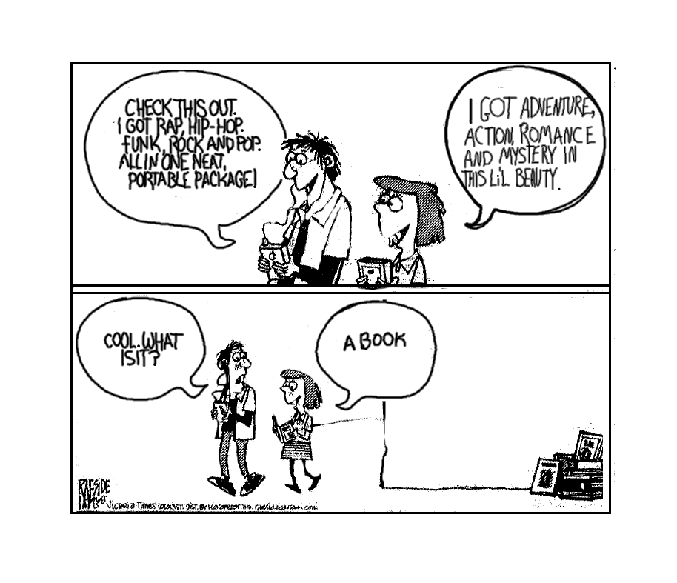
In this part of the examination, there are five selected response questions, each with a value of one mark, and one constructed response question with a value of five marks. Examine the visual and answer the questions that follow. For each selected response question, shade the appropriate response on the bubble sheet. For the constructed response question, write your answer in the space provided, using complete sentences.

Selected Response Questions:
Shade the letter of the correct or best response on the computer-scorable answer sheet.

- What form best describes the visual?

- advertisement
- cartoon
- photojournal
- poster

- Who is the target audience for this visual?

  - editors
  - educators
  - parents
  - youth

- Which best describes the intended purpose of the visual?

- advertise
- argue
- entertain
- inspire

- What visual effect is achieved by the positioning of the speech balloons in the first frame?

- balance
- contrast
- perspective
- scale

- What best describes the tone of the visual?

- critical
- enraged
- nostalgic
- remorseful

Constructed Response:
Write your answer in the space provided.

- Explain how the message in the visual is developed using one visual element and one textual element. (5%)

________________________________________________________________________________________________________________________________________________________________________________________________________________________________________________________________________________________________________________________________________________________________________________________________________________________________________________________________________________________________________________________________________________________________________________________________________________
______________________________________________________________________________________________________________________________________________________________________________________________________________________________________________________________________________________________________________________________________________________________________________________________________________________________________________________________________________________________________________________________________________________________________________________________________________________________________________________________________________________________________________________________________________________________________________________________________________________________________________________________________________________________________________________________________________________________________________________________________________________________________________________________________________________________________________________________________________________
PART II (PROSE) Value 20%
In this part of the examination, there are ten selected response questions, each with a value of one mark, and two constructed response questions with a combined value of ten marks. Read the prose and answer the questions that follow. For each selected-response question, shade the letter of the best or correct response on the bubble sheet. For the constructed response questions, write your answers in the space provided using complete sentences.

Adapted from An Ode to the User-Friendly Pencil
By Bonnie Laing
Recently I acquired a computer. Or perhaps I should say it acquired me. My therapist claims that acknowledging the superior partner in a destructive relationship is the first step toward recovery. I should point out that prior to this acquisition, my idea of modern technology at its best was frozen waffles. My mastery of business machines had advanced only as far as the stapler. | 1
I was persuaded to make this investment by well-meaning friends who said the word-processing capacity of a computer would make me a better writer, make me a more productive writer, and make me a richer writer. I pointed out that Chaucer was a pretty good writer even though he used a quill, and Dickens managed to produce 15 novels and numerous collections of short stories without so much as a typewriter. But I have to admit that option C got to me, even if I couldn’t figure out how spending $3,000 on a piece of molded plastic was going to make me wealthier. | 2
To date, my association with the computer has not been too successful. It has proven to be very sensitive to everything but my needs. At the last breakdown (its, not mine) the service man commented that it should have been called an Edsel not an Epson, and suggested an exorcist be consulted. Needless to say, I am not yet in a position to open a numbered Swiss bank account. | 3
But they say hardship teaches you who your friends are. And so, my computer experience has forced me to spend a lot more time with an old friend, the pencil. Its directness and simplicity have proven to be refreshing. In fact, the more I wrestled with my microchips (whatever they are), the more convinced I became that the pencil is superior to the computer. Allow me to cite a few examples. | 4
To start with the purchase decision, you don’t have to ask for a bank loan to buy a pencil. Since most pencils are not manufactured in Japan, you don’t feel you’re upsetting the nation’s balance of trade by buying one. In fact, pencils are constructed in part from that most Canadian of natural resources — wood. By buying pencils you create employment and prosperity for dozens of people in British Columbia. Well, a few anyway. | 5
Of course, like most people I rarely buy a pencil, preferring to pick them up free from various places of employment, in the mistaken belief that they are a legitimate fringe benefit. It’s best not to make that assumption about office computers. | 6
Operationally, the pencil wins over the computer hands down. You can learn to use a pencil in less than 10 seconds. Personally, at the age of 2, I mastered the technology in 3.2 seconds. To be fair, erasing did take a further 2.4 seconds. I’ve never had to boot a pencil, to interface with it or to program it. I just write with it. | 7
Compared to a computer, a pencil takes up far less space on a desk and it can be utilized in a car, bathroom or a telephone booth without the aid of batteries. You can even use one during an electrical storm. Pencils don’t cause eye strain and no one has ever screamed, after four hours of creative endeavour, “The - - - - pencil ate my story!” | 8
Pencils are wonderfully single-minded. They aren’t used to open car doors, make the morning coffee or remind you that your Visa payment is overdue. They’re user-friendly. (For the uninitiated, see comments on vocabulary.) | 9
Of course, the technologically addicted among you will argue that the options of a pencil are rather limited. But the software of a pencil is both cheap and simple, consisting of a small rubber tip located at one end of the unit. A pencil is capable of producing more fonts or typefaces than any word processor, depending on the operator’s skill. Its graphic capability is limited only by the operator’s talent, an element referred to as the Dürer or Da Vinci Factor. Backup to a pencil can usually be found in your purse or pocket. Although a pencil has no memory, many of us who write badly consider that to be an advantage. But it’s in the area of maintenance that the pencil really proves its superiority. Should a pencil break down, all you have to do to render it operational again, is buy a small plastic device enclosing a sharp metal strip, a purchase that can be made for under a dollar. A paring knife, a piece of broken glass or even your teeth can be used in an emergency. For the more technically advanced, an electronic pencil sharpener can be obtained, but I should point out that these devices don’t run on electrical power but by devouring one-third of the pencil. | 10
You never have to take a pencil to a service department located on an industrial site on the outskirts of Moose Factory. Neither do you have to do without them for two weeks before discovering that the malfunction is not covered by the warranty and that the replacement part is on a boat from Korea. | 11
What finally won me over to the pencil was its lack of social pretension. For instance, very few people suffer the nagging doubt that their intelligence is below that of a pencil. No one has ever claimed that a pencil put them out of a job. And the pencil has not created a whole new class of workers who consider themselves superior to, let’s say, crayon operators. At parties, you meet very few people who will discuss pencils with a fervour normally found only at student rallies in Tehran. Fewer people boast about being ‘pencil literate.’ | 12
Of course, the pencil is not without its flaws. It has a nasty habit of hiding when most needed. If located beside a telephone, it will break spontaneously if a caller wishes to leave a message. Those aspiring to be professional writers should note that editors are unreasonably prejudiced against submissions in pencil. | 13
But a pencil won’t argue with you if you wish to write more than 50 lines to the page. It won’t insist on correcting your whimsical use of grammar, and it won’t be obsolete 10 seconds after you mortgage your first-born to buy one. Just in case you remain unconvinced, I ask you, can you imagine chewing on a computer while balancing your cheque book? And what do computer operators use to scratch that place in the middle of the back where they can’t reach? The defense rests. | 14
Selected Response Questions:
Shade the letter of the correct or best response on the computer-scorable answer sheet.

      - Which best describes the author’s style of writing?

- descriptive
- informal
- narrative
- technical

      - What is the purpose of paragraph 1?

- assess the advantages of modern technology
- encourage people to buy a computer
- engage the reader’s interest with the topic
- establish the objectivity of the writer

      - Which literary device is used in paragraph 2?

        - allegory
        - allusion
        - parable
        - paradox

      - What point of view is used in this selection?

        - first person
        - second person
        - third person limited
        - third person omniscient

      - “Recently I acquired a computer. Or perhaps I should say it acquired me.” (paragraph 1) is an example of which literary device?

        - metaphor
        - oxymoron
        - paradox
        - personification

      - What type of sentence structure is used in the line “The defense rests.” (paragraph 14)?

        - complex
        - compound
        - fragment
        - Simple

      - What does the word “whimsical” mean (paragraph 14)?

        - accurate
        - light-hearted
        - mocking
        - serious

      - How is paragraph 13 primarily developed?

        - analogy
        - counter-argument
        - narration
        - process analysis

      - What is the primary method of development used in the selection?

        - cause and effect
        - chronological order
        - compare and contrast
        - expert opinion

      - Which quotation best expresses the main idea of the selection?

        - “Operationally, the pencil wins over the computer hands down” (paragraph 7).
        - “Pencils are wonderfully single-minded” (paragraph 9).
        - “The technologically addicted among you will argue that the options of a pencil are rather limited” (paragraph 10).
        - “To date, my association with the computer has not been too successful” (paragraph 3).

Constructed Response:
Write your answer in the space provided.

      - With reference to the selection, explain two ways in which the writer achieved coherence. (6%)
________________________________________________________________________________________________________________________________________________________________________________________________________________________________________________________________________________________________________________________________________________________________________________________________________________________________________________________________________________________________________________________________________________________________________________________________________________________________________________________________________________________________________________________________________________________________________________________________________________________________________________________________________________________________________________________________________________________________________________________________________________________________________________________________________________________________________________________________________________________________________________________________________________________________________________________________________________________________________________________________________________________________________________________________________________________________________________________________________________________________________________________________________
      - With two specific references, explain how the author’s use of humour is effective. (4%)
______________________________________________________________________________________________________________________________________________________________________________________________________________________________________________________________________________________________________________________________________________________________________________________________________________________________________________________________________________________________________________________________________________________________________________________________________________________________________________________________________________________________________________________________________________________________________________________________________________________________________________________________________________________________________________________________________________________________________________________________________________________________________________________________________________________________________________________________________________________________________________________________________________________________________________________________________________________________________________________________________________________________________________________________________________________________________________________________
PART III (POETIC TEXT) VALUE 20%
In this part of the examination, there are ten selected response questions, each with a value of one mark, and two constructed response questions with a combined value of ten marks. Read the poem and answer the questions that follow. For each selected response question, circle the correct or best answer. For the constructed response questions, write your responses in the space provided using complete sentences.

Neuteronomy

The elevator stops at every floor
and nobody opens and closes the door,
and nobody talks to his neighbor anymore
where the neuter computer goes tick,
where the neuter computer goes click. | 5
You call the operator on the telephone
and say Help! I’m in trouble and I’m here all alone!
and all you get back is a phoney dial tone
where the neuter computer goes clank,
where the neuter computer goes blank. | 10
There’s no more teacher to be nice or mean
when you learn your lessons from a teaching machine
and plug in your prayers to the preaching machine
where the neuter computer goes bless
where the neuter computer goes yes. | 15
From when you are born until you are old
the facts of your life are all controlled,
put your dreams on a punch card – don’t staple or fold
where the neuter computer prints file,
where the neuter computer prints smile. | 20
There’s no one to love and no one to hate,
and no more misfortune or chance or fate
in this automated obligated zero perfect state
where the neuter computer goes think,
where the neuter computer goes blink | 25
blink think blink think blink blink blink
blinkthink
thinkblink
blink
think | 30
blink
by Eve Merriam
Selected Response Questions:
Shade the letter of the correct or best response on the computer-scorable answer sheet.

      - What is the form of the poem?

- blank verse
- free verse
- lyric
- sonnet

      - “where the neuter computer goes clank” (line 9) is an example of which literary device?

- metaphor
- onomatopoeia
- personification
- simile

      - “and plug in your prayers to the preaching machine” (line 13) is an example of which literary device?

- alliteration
- allusion
- apostrophe
- assonance

      - “and no more misfortune or chance or fate” (line 22) is an example of which literary device?

- analogy
- contrast
- parallel structure
- sentence fragment

      - Which best states the theme?

- computers are essential in our daily lives
- computer technology is enhancing education
- in an over-computerized world people no longer think
- we live in a perfect world

      - What is the rhyme scheme of this poem?

        - aaabb
        - aabbc
        - ababa
        - abcdd

      - What are the implications of, “There is no teacher to be nice or mean” (line 11)?

        - all teachers will be unemotional
        - classrooms will no longer exist
        - education will no longer be important
        - teachers will come to homes

      - In the context of the poem, what does “automated” (line 23) mean?

        - controlled
        - planned
        - programmed
        - restricted

      - What is the purpose of repeating where in the last two lines of each stanza?

        - emphasize importance of computer
        - familiarize reader with computer sounds
        - indicate response of computer
        - specify setting of the poem

      - What does, “the facts of your life are all controlled” (line 17) mean?

        - computers and technology control our lives
        - everything about our lives is recorded somewhere
        - our lives are impacted by the education system
        - the government controls every aspect of our lives

Constructed Response:
Write your answers in the space provided.

      - How does the diction contribute to tone? Use two specific references to support your answer. (6%)
______________________________________________________________________________________________________________________________________________________________________________________________________________________________________________________________________________________________________________________________________________________________________________________________________________________________________________________________________________________________________________________________________________________________________________________________________________________________________________________________________________________________________________________________________________________________________________________________________________________________________________________________________________________________________________________________________________________________________________________________________________________________________________________________________________________________________________________________________________________________________________________________________________________________________________________________________________________________________________________________________________________________________________________________________________________________________________________________
      - Explain how the repetition of the lines: “where the neuter computer goes …” is effective. (4%)
______________________________________________________________________________________________________________________________________________________________________________________________________________________________________________________________________________________________________________________________________________________________________________________________________________________________________________________________________________________________________________________________________________________________________________________________________________________________________________________________________________________________________________________________________________________________________________________________________________________________________________________________________________________________________________________________________________________________________________________________________________________________________________________________________________________________________________________________________________________________________________________________________________________________________________________________________________________________________________________________________________________________________________________________________________________________________________________________

PART IV (CONNECTIONS) VALUE 10%

      - In a two-paragraph response compare the attitude towards technology in the poem Neuteronomy and the prose selection An Ode to the User-Friendly Pencil.
____________________________________________________________________________________________________________________________________________________________________________________________________________________________________________________________________________________________________________________________________________________________________________________________________________________________________________________________________________________________________________________________________________________________________________________________________________________________________________________________________________________________________________________________________________________________________________________________________________________________________________________________________________________________________________________________________________________________________________________________________________________________________________________________________________________________________________________________________________________________________________________________________________________________________________________________________________________________________________________________________________________________________________________________________________________________________________________________________________________________________________________________________________________________________________________________________________________________________________________________________________________________________________________________________________________________________________________________________________________________________________________________________________________________________________________________________________________________________________________________________________________________________________________________________________________________________________________________________________________________________________________________________________________________________________________________________________________________________________________________________________________________________________________________________________________________________________________________________________________________________________________________________________________________________________________________________________________________________________________________________________________________________________________________________________________________________________________________________________________________________________________________________________________________________________________________________________________________________________________________________________________________________________________________________________________________________________________________________________________________________________________________________________________________________
PART V (COMPARATIVE STUDY) VALUE 25%

Responses are marked on the basis of the arguments presented, the specific references to works (content), organization, sentence fluency, voice, word choice, and conventions.

      - In literature, conflict is often used to develop theme. With reference to one longer play and one prescribed novel, write an essay supporting this statement.
__________________________________________________________________________________________________________________________________________________________________________________________________________________________________________________________________________________________________________________________________________________________________________________________________________________________________________________________________________________________________________________________________________________________________________________________________________________________________________________________________________________________________________________________________________________________________________________________________________________________________________________________________________________________________________________________________________________________________________________________________________________________________________________________________________________________________________________________________________________________________________________________________________________________________________________________________________________________________________________________________________________________________________________________________________________________________________________________________________________________________________________________________________________________________________________________________________________________________________________________________________________________________________________________________________________________________________________________________________________________________________________________________________________________________________________________________________________________________________________________________________________________________________________________________________________________________________________________________________________________________________________________________________________________________________________________________________________________________________________________________________________________________________________________________________________________________________________________________________________________________________________________________________________________________________________________________________________________________________________________________________________________________________________________________________________________________________________________________________________________________________________________________________________________________________________________________________________________________________________________________________________________________________________________________________________________________________________________________________________________________________________________________________________________________________________________________________________________________________________________________________________________________________________________________________________________________________________________________________________________________________________________________________________________________________________________________________________________________________________________________________________________________________________________________________________________________________________________________________________________________________________________________________________________________________________________________________________________________________________________________________________________________________________________________________________________________________________________________________________________________________________________________________________________________________________________________________________________________________________________________________________________________________________________________________________________________________________________________________________________________________________________________________________________________________________________________________________________________________________________________________________________________________________________________________________________________________________________________________________________________________________________________________________________________________________________________________________________________________________________________________________________________________________________________________________________________________________________________________________________________________________________________________________________________________________________________________________________________________________________________________________________________________________________________________________________________________________________________________________________________________________________________________________________________________________________________________________________________________________________________________________________________________________________________________________________________________________________________________________________________________________________________________________________________________________________________________________________________________________________________________________________________________________________________________________________________________________________________________________________________________________________________________________________________________________________________________________________________________________________________________________________________________________________________________________________________________________________________________________________________________________________________________________________________________________________________________________________________________________________________________________________________________________________________________________________________________________________________________________________________________________________PART VI (PERSONAL RESPONSE) VALUE 15%
Responses are marked on the basis of content, organization, sentence fluency, voice, word choice, and conventions.

“The real danger is not that computers will begin to think like [people], but that [people] will begin to think like computers.” -- Sydney J. Harris

      - Respond to the quote using one of the forms below.

Possible forms:
Editorial
Letter to Editor
Newspaper Article
Short Story
Monologue
Narrative Essay
Expository Essay

__________________________________________________________________________________________________________________________________________________________________________________________________________________________________________________________________________________________________________________________________________________________________________________________________________________________________________________________________________________________________________________________________________________________________________________________________________________________________________________________________________________________________________________________________________________________________________________________________________________________________________________________________________________________________________________________________________________________________________________________________________________________________________________________________________________________________________________________________________________________________________________________________________________________________________________________________________________________________________________________________________________________________________________________________________________________________________________________________________________________________________________________________________________________________________________________________________________________________________________________________________________________________________________________________________________________________________________________________________________________________________________________________________________________________________________________________________________________________________________________________________________________________________________________________________________________________________________________________________________________________________________________________________________________________________________________________________________________________________________________________________________________________________________________________________________________________________________________________________________________________________________________________________________________________________________________________________________________________________________________________________________________________________________________________________________________________________________________________________________________________________________________________________________________________________________________________________________________________________________________________________________________________________________________________________________________________________________________________________________________________________________________________________________________________________________________________________________________________________________________________________________________________________________________________________________________________________________________________________________________________________________________________________________________________________________________________________________________________________________________________________________________________________________________________________________________________________________________________________________________________________________________________________________________________________________________________________________________________________________________________________________________________________________________________________________________________________________________________________________________________________________________________________________________________________________________________________________________________________________________________________________________________________________________________________________________________________________________________________________________________________________________________________________________________________________________________________________________________________________________________________________________________________________________________________________________________________________________________________________________________________________________________________________________________________________________________________________________________________________________________________________________________________________________________________________________________________________________________________________________________________________________________________________________________________________________________________________________________________________________________________________________________________________________________________________________________________________________________________________________________________________________________________________________________________________________________________________________________________________________________________________________________________________________________________________________________________________________________________________________________________________________________________________________________________________________________________________________________________________________________________________________________________________________________________________________________________________________________________________________________________________________________________________________________________________________________________________________________________________________________________________________________________________________________________________________________________________________________________________________________________________________________________________________________________________________________________________________________________________________________________________________________________________________________________________________________________________________________________________________________________________________________________________________________________________________________________________________________________________________________________________________________________________________________________________________________________________________________________________________________________________________________________________________________________________________________________________________________________________________________________________________________________________________________________________________________________________________________________________________________________________________________________________________________________________________________________________________________________________________________________________________________________________________________________________________________________________________________________________________________________________________________________________________________________________________________________________________________________________________________________________________________________________________________________________________________________________________________________________________________________________________________________________________________________________________________________________________________________________________________________________________________________________________________________________________________________________________________________________________________________________________________________________________________________________________________________________________________________________________________________________________________________________________________________________________________________________________________________________________________________________________________________________________________________________________________________________________________________________________________________________________________________________________________________________________________________________________________________________________________________________________________________________________________________________________________________________________________________________________________________________________________________________________________________________________________________________________________________________________________________________________________________________________________________________________________________________________________________________________________________________________________________________________________________________________________________________________________________________________________________________________________________________________________________________________________________________________________________________________________________________________________________________________________________________________________________________________________________________________________________________________________________________________________________________________________________________________________________________________________________________________________________________________________________________________________________________________________________________________________________________________________________________________________________________________________________________________________________________________________________________________________________________________________________________________________________________________________________________________________________________________________________________________________________________________________________________________________________________________________________________________________________________________________________________________________________________________________________________________________________________________________________________________________________________________________________________________________________________________________________________________________________________________________________________________________________________________________________________________________________________________________________________________________________________________________________________________________________________________________________________________________________________________________________________________________________________________________________________________________________________________________________________________________________________________________________________________________________________________________________________________________________________________________________________________________________________________________________________________________________________________________________________________________________________________________________________________________________________________________________________________________________________________________________
__________________________________________________________________________

