PART I (VISUAL) VALUE 10%
In this part of the examination, there are five selected response questions, each with a value of one mark, and one constructed response question with a value of five marks. Examine the visual and answer the questions that follow. For each selected response question, shade the appropriate response on the bubble sheet. For the constructed response question, write your answer in the space provided, using complete sentences.
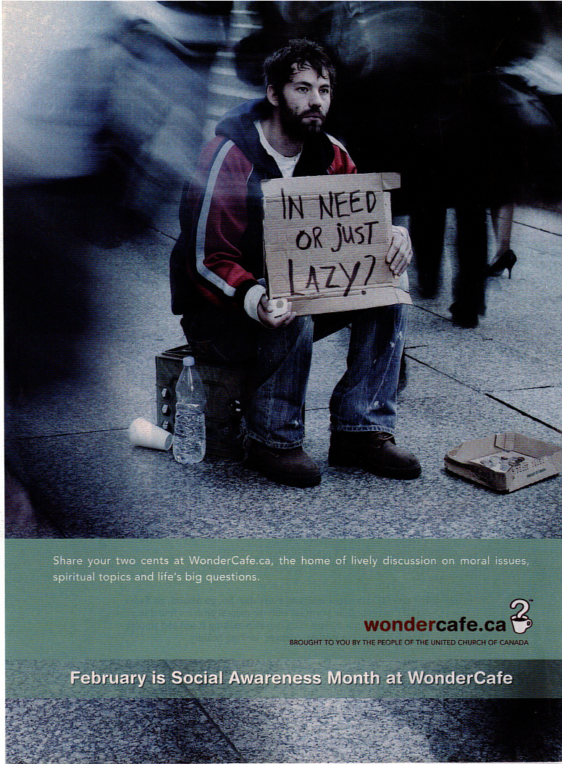

Selected Response Questions:
Shade the letter of the correct or best response on the computer-scorable answer sheet.

- What is the logo for the visual?

  - in need or just lazy
  - mug and question mark
  - social awareness month
  - wondercafe.ca

- What is the purpose of the visual?

  - donate money
  - provide instruction
  - religious awareness
  - social awareness

- What form of figurative language is the phrase “share your two cents”?

  - hyperbole
  - metaphor
  - onomatopoeia
  - oxymoron

- What best describes the phrase, “the home of lively discussion”?

  - allusion
  - imagery
  - irony
  - symbolism

- Which word best represents the character in the visual?

  - ambitious
  - confused
  - determined
  - stereotyped

Constructed Response:
Write your answer in the space provided.

- How does the author develop the focal point? Provide two references to support your answer. (5%)
________________________________________________________________________________________________________________________________________________________________________________________________________________________________________________________________________________________________________________________________________________________________________________________________________________________________________________________________________________________________________________________________________________________________________________________________________________________________________________________________________________________________________________________________________________________________________________________________________________________________________________________________________________________________________________________

PART II (PROSE) Value 20%
In this part of the examination, there are eight selected response questions, each with a value of one mark, and two constructed response questions with a combined value of twelve marks. Read the prose and answer the questions that follow. For each selected-response question, shade the letter of the best or correct response on the bubble sheet. For the constructed response questions, write your answers in the space provided using complete sentences.

Disqualified
by Tony Collins
Like a lot of Newfoundlanders with a rural background, my friend Hayward seems to be able to do just about anything he sets his mind to. | 1
While the rest of us mere mortals deem ourselves lucky to possess one marketable skill, Hayward is blessed with an aptitude for everything, whether that be installing kitchen cabinets, paunching a moose, or rebuilding an engine and not ending up with a box full of leftover parts. | 2
Hayward didn't go to university or what used to be called the trade school. In high school his teachers all said he lacked ambition, an opinion with which Hayward was in complete agreement. | 3
You see, Hayward figured he didn't need ambition, considering he was already happy living where he was, and was more than capable of doing the things that had to be done, like building his own house, fixing his own car, and growing vegetables to get himself and his family through the winter. | 4
Among his many talents, Hayward has an amazing gift for coming up with the simplest possible solution to virtually every problem. It's what's referred to as Occam's Razor, whereby all unnecessary facts or constituents in the subject being analyzed are to be eliminated. Hayward does that almost instinctively and quite nonchalantly, as if the right answer should be perfectly obvious to everyone else as well - which it isn't. | 5
One of the questions the computer software giant, Microsoft, asks of its prospective employees is why manhole covers are round. It's supposed to test intuitive thinking and the ability to reason logically. | 6
Hayward didn't need to think about it. As far as he was concerned the answer was as plain as the nose on his face. | 7
"Well, b'y," he responded immediately, "if they were square they could fall down the hole and land on your head." | 8
I didn't tell him I'd spent the better part of an afternoon wracking my brains trying to come up with the answer. | 9
The other day I sought Hayward's advice on how best to fix an old ping pong table I had lying around in the basement. The wooden table top fits down into a metal frame but most of the screws holding it in place had come loose or fallen out altogether. For the life of me, I couldn't figure out any way of repairing it short of buying a whole new top, at considerable expense. | 10
He thought about it for 30 seconds. | 11
"Why don't you just drill new holes?" he asked. "Shouldn't cost more than a dollar or two for a few new screws." | 12
Eureka! | 13
Hayward built a cabin up in the woods a while ago. He cut all his own logs and had them sawed on the halves. He was most of the summer getting the frame and roof up, in between working on an Employment Insurance top-up project, fibre glassing his boat, wiring his next door neighbour's house, paving his driveway with second-hand asphalt he'd scrounged off the highways department, and putting a new motor in his Dodge pickup. | 14
Hayward also does his own painting and plastering, and can wield a chainsaw with the dexterity and finesse of a surgeon. His skills as a plumber are legendary, and on occasion he's been known to try his hand at welding. At the moment he's busy refinishing some chairs for his wife, and the volunteer fire brigade wants him to do some renovations down at the hall (on a volunteer basis, of course). He told them he can't do anything until after he gets his moose, which may not be any time soon, seeing as how he's got a bull-only licence for Area 23. | 15
Before the moratorium Hayward used to fish with his two brothers. They built their own longliner and after the trap voyage was over they'd go handling and jigging on the Offer Banks. Usually they'd make enough money to see them through until early spring, when the seal hunt started up. Hayward's a crack shot with a rifle and can skulp out a seal in under five minutes. | 16
Hayward also knows which way is north, and when the rabbits are starting to change colour, how to castrate a pig (an art in itself), where to find the best berries, and exactly what to do in any and all emergencies. And when his children were smaller he used to make up little poems for them, every night before they went to bed. | 17
When his youngest brother was killed in a car accident up in Alberta last year, Hayward delivered the eulogy. | 18
Yup...Hayward can do just about everything. The only thing he hasn't been able to do lately is find a job. | 19
They say he lacks the necessary qualifications. | 20

Selected Response Questions:
Shade the letter of the correct or best response on the computer-scorable answer sheet.

- “While the rest of us mere mortals...” (paragraph 2) is what type of figurative language?

  - alliteration
  - allusion
  - onomatopoeia
  - metaphor

- What is the point of view in this text?

  - first person
  - second person
  - third person limited
  - third person omniscient

- Which best describes “Well, b’y,” (paragraph 8)?

  - aside
  - dialect
  - monologue
  - sarcasm

- What part of speech is “Eureka!” (paragraph 13)?

  - conjunction
  - interjection
  - noun
  - verb

- “... and can wield a chainsaw with the dexterity and finesse of a surgeon” (paragraph 12) is what type of figurative language?

  - assonance
  - metaphor
  - personification
  - simile

- What word would best describe the character of Hayward?

  - careful
  - resourceful
  - sluggish
  - unimaginative

- Which reflects the narrator’s feelings towards Hayward?

  - admiration
  - compassion
  - contempt
  - jealousy

- In the context of paragraph 6, what is the meaning of “intuitive thinking”?

  - mystified
  - confused
  - perceptive
  - psychic

Constructed Response:
Write your answer in the space provided.

- Find and explain an example of irony. Support your answer with two references to the selection. (6%)
______________________________________________________________________________________________________________________________________________________________________________________________________________________________________________________________________________________________________________________________________________________________________________________________________________________________________________________________________________________________________________________________________________________________________________________________________________________________________________________________________________________________________________________________________________________________________________________________________________________________________________________________________________________________________________________________________________________________________________________________________________________________________________________________________________________________________________________________________________________

- State a possible theme for Disqualified. Support you answer with reference to the title and one from the text. (6%)
______________________________________________________________________________________________________________________________________________________________________________________________________________________________________________________________________________________________________________________________________________________________________________________________________________________________________________________________________________________________________________________________________________________________________________________________________________________________________________________________________________________________________________________________________________________________________________________________________________________________________________

PART III (POETIC TEXT) VALUE 20%
In this part of the examination, there are nine selected response questions, each with a value of one mark, and two constructed response questions with a combined value of eleven marks. Read the poem and answer the questions that follow. For each selected response question, circle the correct or best answer. For the constructed response questions, write your responses in the space provided using complete sentences.

Then
poverty teaches no one
it's just dark and small
like a revolver
always ready to be
the final judge | 5
i remember dirty walls
macaroni, television and
dumping the slop pail
there was no beauty
you just survived | 10
between paydays
my father
drank every Friday
and saturday nights
he lived between the | 15
borders of the day shift
and the night shift
that was the only
structure i knew
i know now | 20
that he sold
what little of himself
he had so that i could eat
what kind of change is that?
where one generation sacrifices | 25
itself so that the next one
can walk on its bones
with a new pair of shoes.

by Robert Hilles.

Selected Response Questions:
Shade the letter of the correct or best response on the computer-scorable answer sheet.

- What is the form of the poem?

- free verse
- ballad
- blank verse
- sonnet

- “it’s just dark and small / like a revolver” (lines 2-3) is what type of figurative language?

  - hyperbole
  - metaphor
  - personification
  - simile

- “a revolver / always ready to be / the final judge” (lines 2-5) is what type of figurative language?

- onomatopoeia
- oxymoron
- personification
- understatement

- Which best describes “what kind of change is that?” (line 24)?

- colloquial
- lyrical
- literal
- rhetorical

- “dirty walls / macaroni, television and / dumping the slop pail” (lines 6-8) is an example of which literary device?

- alliteration
- hyperbole
- metaphor
- parallelism

- Which best describes the change in tone in the poem?

- harsh to despair
- reflective to pessimistic
- resentful to appreciative
- thankful to bitter

- What does the narrator mean in lines 21-22, “that he sold / what little of himself he had”?

- auctioned himself to the highest bidder
- compromised his goals
- forfeited his own dreams
- sold himself into slavery

- What is the significance of the title?

- develops dramatic irony
- emphasizes perspective
- illustrates setting
- indicates the past

- What do the shoes symbolize?

- better life
- cruel acts
- greed
- sacrifice

Constructed Response:
Write your answers in the space provided.

- How does the speaker’s maturity affect his/her view of the father? Support your response with two references to the selection. (6%)
________________________________________________________________________________________________________________________________________________________________________________________________________________________________________________________________________________________________________________________________________________________________________________________________________________________________________________________________________________________________________________________________________________________________________________________________________________________________________________________________________________________________________________________________________________________________________________________________________________________________________________________________________________________________________________________________________________________________________________________________________________________________________________________________________________________________________________________________________________________________________________________________________________________________________________________________________________________________________________________________________________________________________________________________________________________________________________________________________________________________________________________________________

- Discuss the author’s effective use of imagery. Provide two examples to support your answer. (5%)
____________________________________________________________________________________________________________________________________________________________________________________________________________________________________________________________________________________________________________________________________________________________________________________________________________________________________________________________________________________________________________________________________________________________________________________________________________________________________________________________________________________________________________________________________________________________________________________________________________________________________________________________________________________________________________________________________________________________________________________________________________________________________________________________________________________________________________________________________________________________________________________________________________________________________________________________________________________________________________________________________________________________________________________
PART IV (CONNECTIONS) VALUE 10%
- In a two-paragraph response, compare the attitudes towards the main character reflected in the prose selection and the visual selection. Use one specific reference from each text to show similarity and one specific reference from each to show contrast.

________________________________________________________________________________________________________________________________________________________________________________________________________________________________________________________________________________________________________________________________________________________________________________________________________________________________________________________________________________________________________________________________________________________________________________________________________________________________________________________________________________________________________________________________________________________________________________________________________________________________________________________________________________________________________________________________________________________________________________________________________________________________________________________________________________________________________________________________________________________________________________________________________________________________________________________________________________________________________________________________________________________________________________________________________________________________________________________________________________________________________________________________________________________________________________________________________________________________________________________________________________________________________________________________________________________________________________________________________________________________________________________________________________________________________________________________________________________________________________________________________________________________________________________________________________________________________________________________________________________________________________________________________________________________________________________________________________________________________________________________________________________________________________________________________________________________________________________________________________________________________________________________________________________________________________________________________________________________________________________________________________________________________________________________________________________________________________________________________________________________________________________________________________________________________________________________________________________________________________________________________________________________________________________________________________________________________________________________________________________________________________________________________________________________________________________________________________________________________________________________________________________________________________________________________________________________________________________________________________
PART V (ESSAY) VALUE 25%

Responses are marked on the basis of the arguments presented, the specific references to the chosen work (content), organization, sentence fluency, voice, word choice, and conventions.

- Authors often use conflict to develop theme. With specific reference to a novel OR a longer play studied this year, discuss how an author develops theme through the use of conflict.
________________________________________________________________________________________________________________________________________________________________________________________________________________________________________________________________________________________________________________________________________________________________________________________________________________________________________________________________________________________________________________________________________________________________________________________________________________________________________________________________________________________________________________________________________________________________________________________________________________________________________________________________________________________________________________________________________________________________________________________________________________________________________________________________________________________________________________________________________________________________________________________________________________________________________________________________________________________________________________________________________________________________________________________________________________________________________________________________________________________________________________________________________________________________________________________________________________________________________________________________________________________________________________________________________________________________________________________________________________________________________________________________________________________________________________________________________________________________________________________________________________________________________________________________________________________________________________________________________________________________________________________________________________________________________________________________________________________________________________________________________________________________________________________________________________________________________________________________________________________________________________________________________________________________________________________________________________________________________________________________________________________________________________________________________________________________________________________________________________________________________________________________________________________________________________________________________________________________________________________________________________________________________________________________________________________________________________________________________________________________________________________________________________________________________________________________________________________________________________________________________________________________________________________________________________________________________________________________________________
________________________________________________________________________________________________________________________________________________________________________________________________________________________________________________________________________________________________________________________________________________________________________________________________________________________________________________________________________________________________________________________________________________________________________________________________________________________________________________________________________________________________________________________________________________________________________________________________________________________________________________________________________________________________________________________________________________________________________________________________________________________________________________________________________________________________________________________________________________________________________________________________________________________________________________________________________________________________________________________________________________________________________________________________________________________________________________________________________________________________________________________________________________________________________________________________________________________________________________________________________________________________________________________________________________________________________________________________________________________________________________________________________________________________________________________________________________________________________________________________________________________________________________________________________________________________________________________________________________________________________________________________________________________________________________________________________________________________________________________________________________________________________________________________________________________________________________________________________________________________________________________________________________________________________________________________________________________________________________________________________________________________________________________________________________________________________________________________________________________________________________________________________________________________________________________________________________________________________________________________________________________________________________________________________________________________________________________________________________________________________________________________________________________________________________________________________________________________________________________________________________________________________________________
PART VI (PERSONAL RESPONSE) VALUE 15%

Responses are marked on the basis of content, organization, sentence fluency, voice, word choice, and conventions.

“It has been my observation that most people get ahead during the time that others waste.” -- Henry Ford

- Respond to the quote using one of the forms below.

Possible forms:
Editorial
Letter to Editor
Newspaper Article
Short Story
Monologue
Narrative Essay
Expository Essay

__________________________________________________________________________________________________________________________________________________________________________________________________________________________________________________________________________________________________________________________________________________________________________________________________________________________________________________________________________________________________________________________________________________________________________________________________________________________________________________________________________________________________________________________________________________________________________________________________________________________________________________________________________________________________________________________________________________________________________________________________________________________________________________________________________________________________________________________________________________________________________________________________________________________________________________________________________________________________________________________________________________________________________________________________________________________________________________________________________________________________________________________________________________________________________________________________________________________________________________________________________________________________________________________________________________________________________________________________________________________________________________________________________________________________________________________________________________________________________________________________________________________________________________________________________________________________________________________________________________________________________________________________________________________________________________________________________________________________________________________________________________________________________________________________________________________________________________________________________________________________________________________________________________________________________________________________________________________________________________________________________________________________________________________________________________________________________________________________________________________________________________________________________________________________________________________________________________________________________________________________________________________________________________________________________________________________________________________________________________________________________________________________________________________________________________________________________________________________________________________________________________________________________________________________________________________________________________________________________________________________________________________________________________________________________________________________________________________________________________________________________________________________________________________________________________________________________
____________________________________________________________________________________________________________________________________________________________________________________________________________________________________________________________________________________________________________________________________________________________________________________________________________________________________________________________________________________________________________________________________________________________________________________________________________________________________________________________________________________________________________________________________________________________________________________________________________________________________________________________________________________________________________________________________________________________________________________________________________________________________________________________________________________________________________________________________________________________________________________________________________________________________________________________________________________________________________________________________________________________________________________________________________________________________________________________________________________________________________________________________________________________________________________________________________________________________________________________________________________________________________________________________________________________________________________________________________________________________________________________________________________________________________________________________________________________________________________________________________________________________________________________________________________________________________________________________________________________________________________________________________________________________________________________________________________________________________________________________________________________________________________________________________________________________________________________________________________________________________________________________________________________________________________________________________________________________________________________________________________________________________________________________________________________________________________________________________________________________________________________________________________________________________________________________________________________________________________________________________________________________________________________________________________________________________________________________________________________________________________________________________________________________________________________________________________________________________________________________________________________________________________________________________________________________________________________________________________________________________________________________________

